# Unit 3 - Lesson 5. The Cost of Efficiency Analysis of Path Finding

# Introduction to Optimization and Decision Making

**Aim:** How do we analyze the cost and efficiency in path finding including maze navigation?

**Objectives:** After the lesson, students should be able to:

* Understand the travelling salesman problem

**CLASS PROCEDURE:**

***Do Now:*** A travelling salesman needs to visit all of the four cities of A, B, C and D. The sequence doesn’t matter but he wants to minimize the costs. The costs of the travel are given on the diagram below. What is the best travel plan?

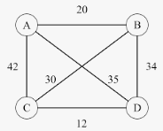

***Class Discussion / Presentation:***

1. If the diagram becomes more complex, like the one give below, is there a certain algorithm that we can follow to solve the traveling salesman problem?

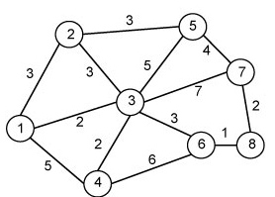

1. Can we use matrices instead of the diagrams to save and analyze the data? What are the benefits of using the matrices?

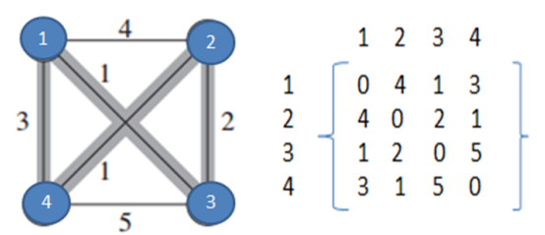

1. Using the cost matrix above, how do we solve the travelling salesman problem?
2. What is the Hungarian Method and how do we use it to solve the travelling salesman problem?

**Pair – sharing Activity:**

Research on Hungarian Method. How do we use the Hungarian method to solve the following traveling salesman problem?

